Intranet blueprint

All your colleagues need to know about Brian
Version: December 12th, 2022

Introduction

Aim of this blueprint | How to use | Development process
The goal of the blueprint is to provide a consolidated and transparent overview of the entire product. This overview is designed in such a way that it can be easily integrated into your intranet and thus serve as a central point of information for your employees' questions about AskBrian. | The guideline contains six chapters. These can either be fully integrated into your intranet or serve as a basic manual, which you can then design to suit your company's specific needs. Text in blue needs to be customized by your company, in orange you’ll find our AskBrian comments. | The blueprint includes industry best practices as well as AskBrian's guidance and ideas. Based on our extensive customer knowledge, we have summarized pain points, FAQs and important information about the product together with our customers in order to provide a ready-to-use, add-on service for you.

Table of contents
1. Overview AskBrian
2. Skills and functionalities
3. How to: Tips & Tricks
4. AskBrian and privacy
5. Filing of webinars, intro sessions, deep dive sessions
6. FAQ

Brian – the fundamentals
- Service intro
Brian is a secure, multifunctional AI-powered digital assistant for consultants and business professionals. He helps with time consuming tasks by providing simple 24/7 access to multiple digital services and data sources boosting your efficiency and happiness.

- How to access Brian
You can reach Brian via brian@askbrian.ai or via the “AskBrian” app in the Microsoft Teams App Store. Best start – ask him “What are your skills?”

- Who has access
Every employee has full access to all skills of Brian. / The following departments have access to Brian’s skills.

- Key benefits
Brian’s services can be accessed 24/7 through MS Teams, via E-Mail or Slack. You will receive your results within seconds or a maximum of 3 minutes. Active Brian users can save 4 - 7 hours per month, enabling you to work smarter.

- Data security and privacy
AskBrian is 100% GDPR compliant and confidential. Therefore, you can share the following file categories with Brian: Public, Internal, Confidential, Strictly confidential.

- Support contact
Should you need any help, please contact internally to Name, position, e-mail, phone or ask the AskBrian support for assistance: support@askbrian.ai

Skills and functionalities
- Skill overview
For the very most actual overview of all skills of Brian you can visit www.askbrian.ai/skills
Brian has multiple skills in four categories:
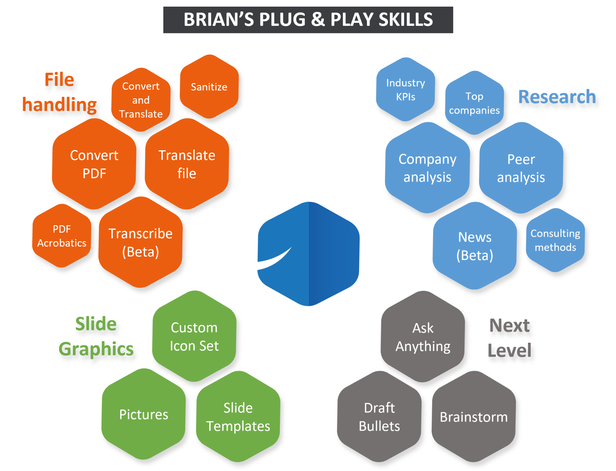

- Cheat sheet
The cheat sheet is a list of all skills of Brian including exemplary formulations and a number of smart links. You can get this helpful one-pager with all skills of Brian via email and MS Teams just by asking “Send me your cheat sheet”
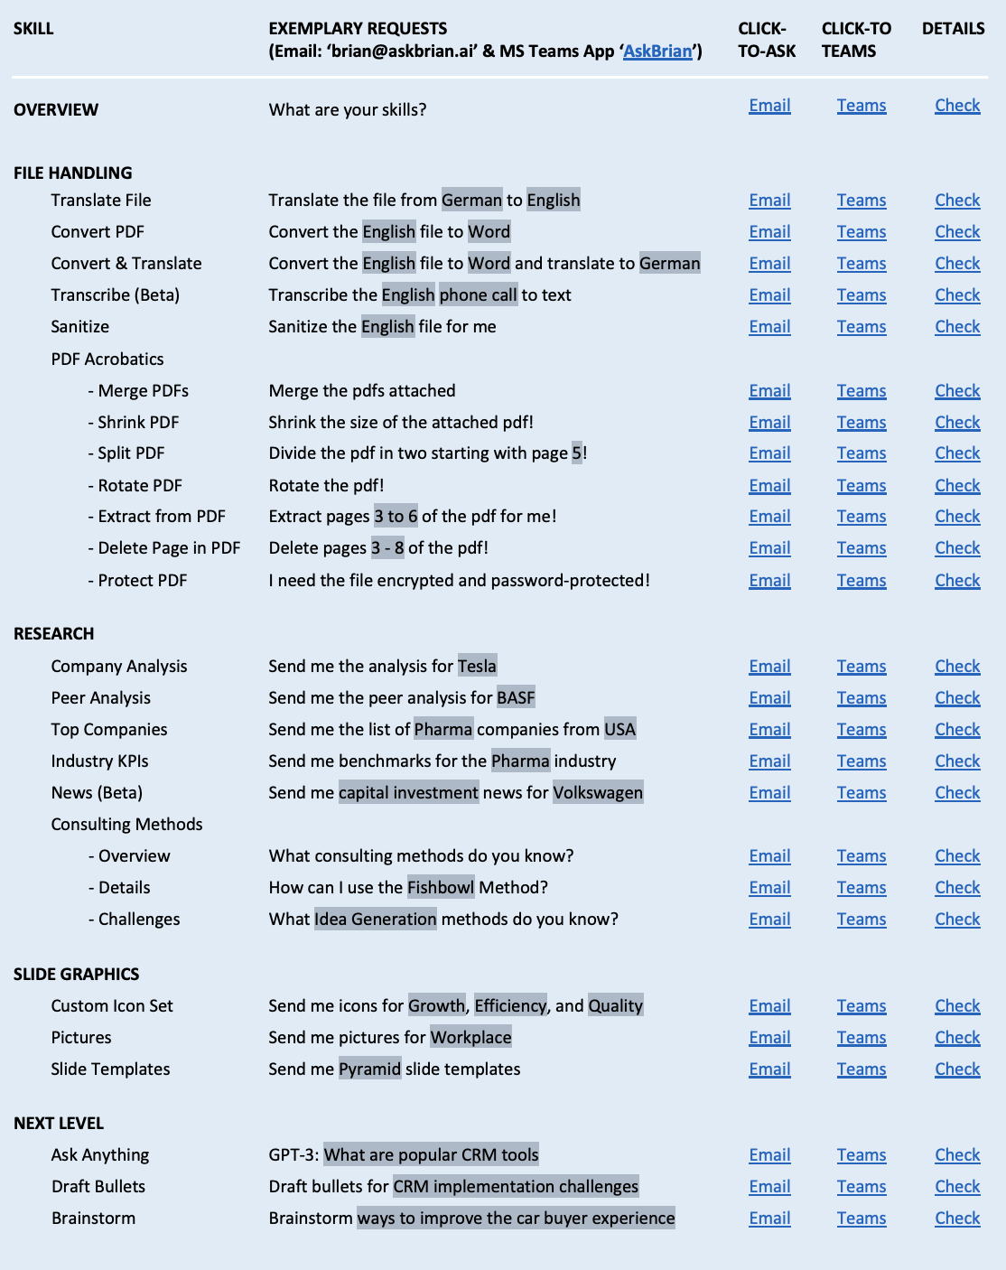

- Deep dive into core skills of Brian
(suggestion, can be modified by your company)

Translate File
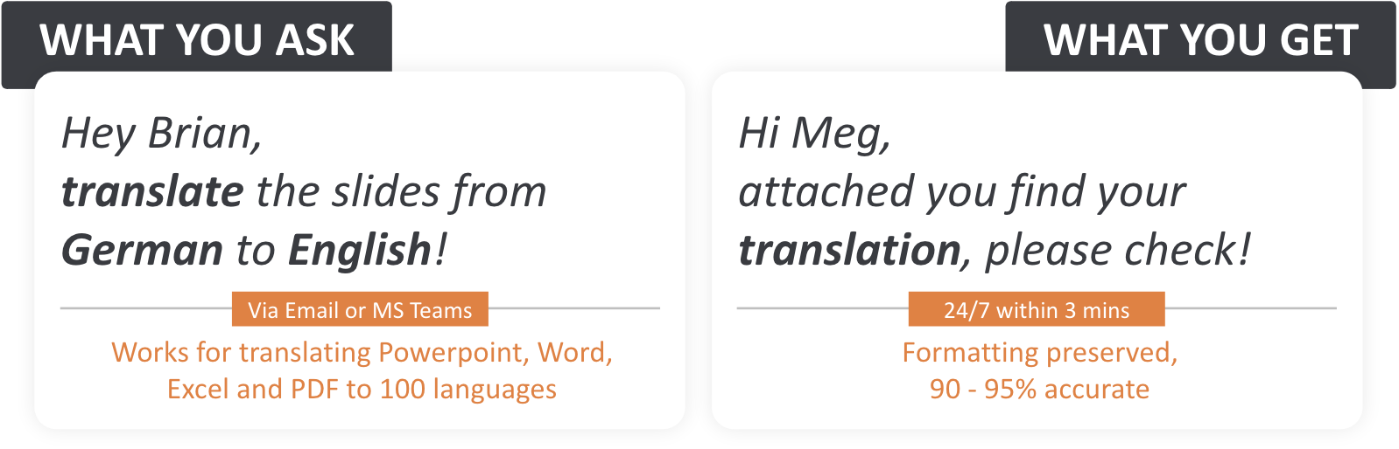
Top Companies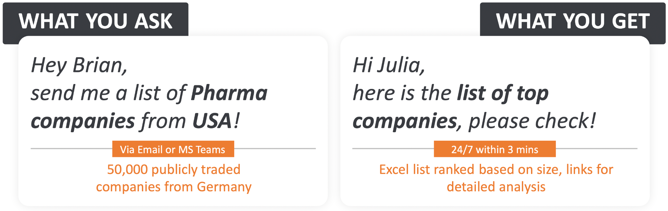

Peer Analysis
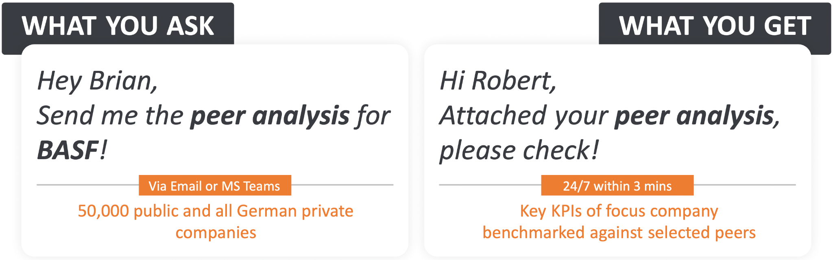
Slide Templates
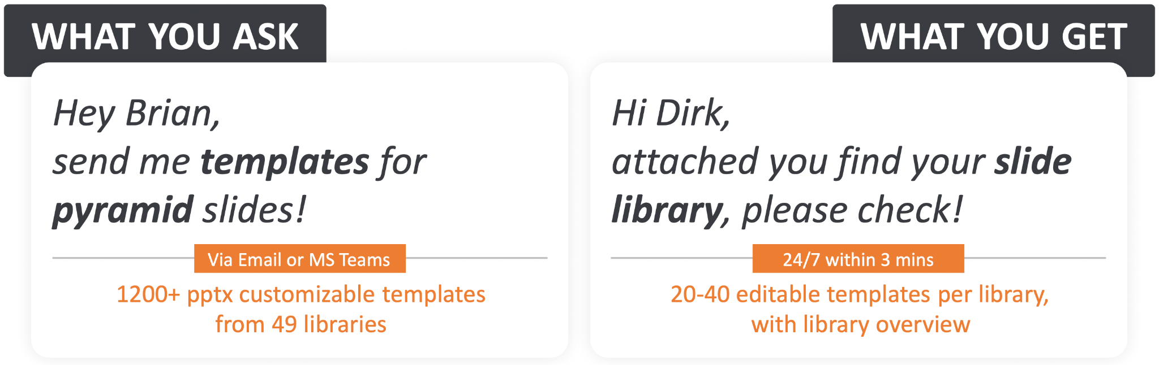

- Reference to AskBrian Skills website with all details for every skill
https://www.askbrian.ai/skills/

- Link to submit your own skill suggestions
Use the contact formular of AskBrian https://www.askbrian.ai/contact-form/

How to: Tips & Tricks
- Getting started via E-mail
You do not to register anywhere or to download anything. Just write an E-mail to brian@askbrian.ai formulating e.g. “Hey Brian, what are your skills” No signup or login on an external site necessary. That’s it. Easy, simple, efficient.

- Getting started via MS Teams
If you want to get started via Teams, you need to go to your Teams Apps and add Brian to your workplace. You do not need to register anywhere or download anything else. This is how you can do it in a very few simple steps: https://www.askbrian.ai/brian-microsoft-teams/

- How to ask Brian for specific information/ How to use Brian via email and via MS Teams?
Use the information in the Cheat Sheet or the guidance at the AskBrian website → https://www.askbrian.ai/how-it-works/

- The next live onboarding sessions:
Link to the onboarding sessions or further information

AskBrian and privacy
- Client documents may be submitted
AskBrian is 100% GDPR compliant and confidential. For further information, please visit https://www.askbrian.ai/security-and-privacy/ or check out the FAQs

- Brian is GDPR compliant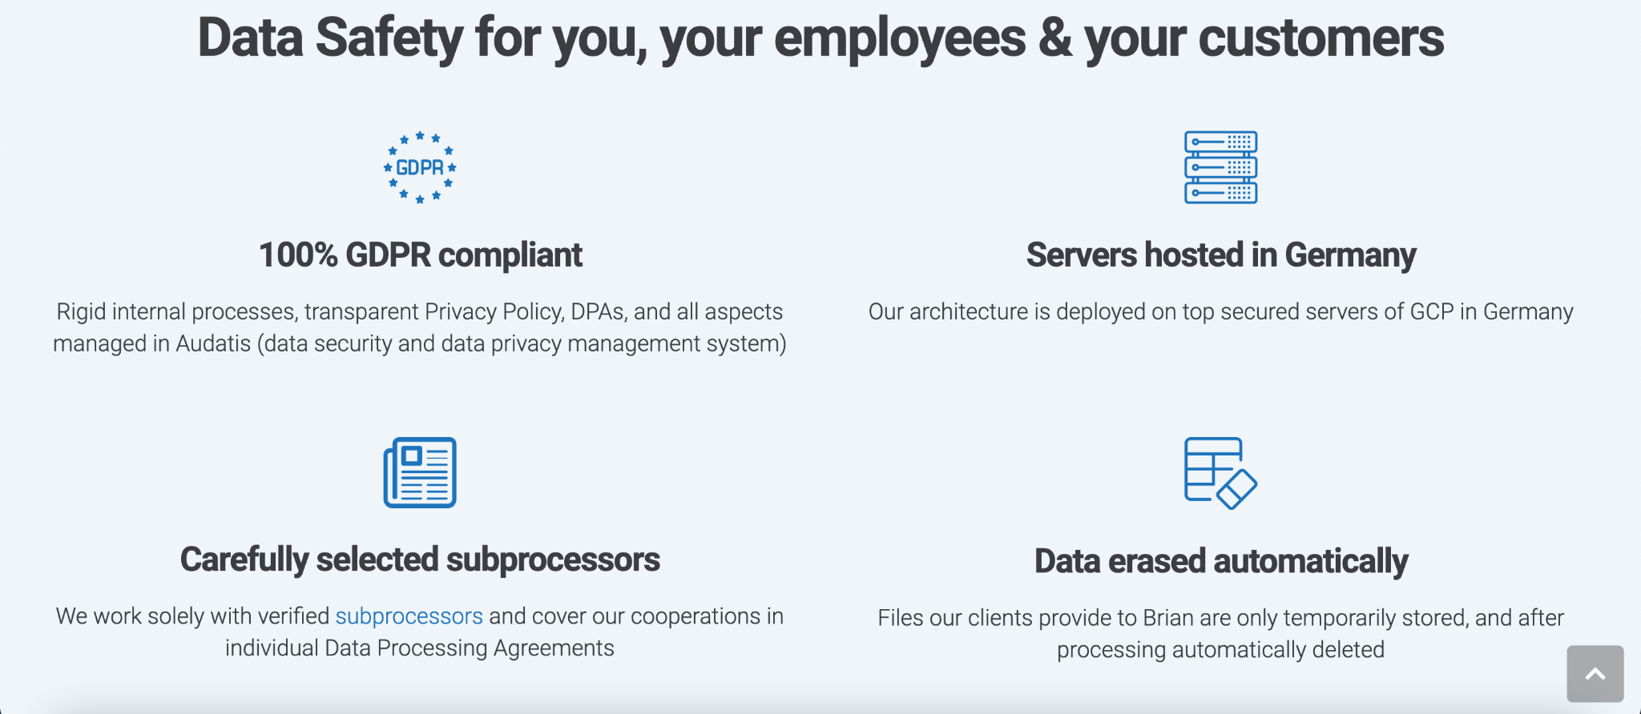
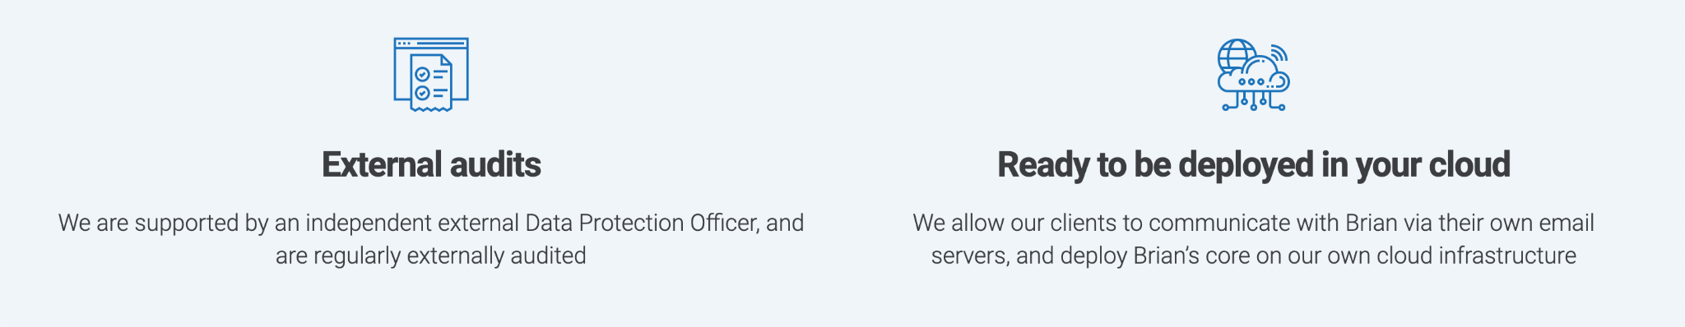

- ISO 27001 compliant
AskBrian passed the ISO 27001 audit in December 2022, the certificate can be shared on request.

- AskBrian's promise for secure data handling
“The protection of you data is our top priority… even beyond the tough legal requirements in Germany.” - Pavol Sikula, CEO & Founder of AskBrian

Webinars, intro sessions, deep dive sessions
- Internal Brian presentation
- Screencasts
- Video call recordings
Note: AskBrian will provide several presentations for onboarding purposes. Moreover, in this section, further documents and recordings can be stored (direct storage, links, etc.)

FAQ
- General information
Q: Can we send client information to Brian?
A: AskBrian is 100% GDPR compliant and confidential.
(Extra input for consultancies: “Therefore, client documents/ material can be submitted.”)
Q: How does AskBrian process our data?
A: Check out the website, where you can find a data processing example for the skill “translation”. https://www.askbrian.ai/security-and-privacy/

Q: What is GPT-3?
A: Generative Pre-trained Transformer 3 is an autoregressive language model that uses deep learning to produce human-like text.

Q: Am I causing additional cost for the company by using Brian?
A: Brian is a prepaid flat-rate service based on the number of expected active users. So the bill is already paid, now we can do the most out of it.

- Goal of providing Brian for the employees
Q: Why did we implement AskBrian within the company?
A: (to be answered by you as the company)
Suggestion: Time savings, focus on valuable tasks, employer satisfaction, work smarter not harder, digital workplace, speed of information provision, …

Q: Do I have to use it?
A: (to be answered by you as the company)
Suggestion: Of course there is no obligation, but you will see, you can save a lot of time, learn what AI is capable of, become familiar with AI-based tools, …

- Data security
Q: Are there any restrictions?
A: No, data security is the foundation of the business model at AskBrian. As the founder Pavol Sikula says: ”The protection of your data is our top priority… even beyond the tough legal requirements in Germany.”

Q: Can I have a closer look at AskBrian’s Privacy Policy and Data Processing Agreement?
A: Sure, just check out the website (https://www.askbrian.ai/security-and-privacy/) and download the Privacy Policy and/ or Data Processing Agreement.

- Quality assurance
Q: Do I have to check the translations?
A: Yes. Even though Brian is highly accurate in translating your documents, there can anytime be formulations you would probably do different.

Q: Are Brian’s results always right?
A: Brian is deterministic and predictable in provided structured information, e.g. for publicly traded companies. Those skills which involve AI are in most cases right and accurate, even though a 100% AI precision and correctness can nowadays not be guaranteed.

- File translations
Q: What distinguishes Brian’s translation from the translation by DeepL?
A: With Brian, you can translate between more languages (over 100), more formats (PDF, pptx, docx, xlsx), in a more convenient way, with a file size limit of 20 MB. And Brian has more skill as well. Still, the quality is equal because AskBrian uses the best services out there (incl. DeepL)

Q: Is there a size limit for files?
A: There is a limit of 20 MB.

Q: Which languages can be translated?
A: Brian translates your documents in more than 100 languages. Just check it out.

Q: Are all translations equally precise?
A: In general, Brian’s translations are 95% accurate and precise. The quality still depending on the language pairs (higher quality of most popular translation pairs)

- Icons and Slides
Q: Are the provided slides and icons compliant with our corporate design?
A: (to be answered by you as the company)

Q: Do we have to re-check the provided results and look out for e.g. alignment issues?
A: Yes. Even though there shouldn’t be any issues with the alignment, a re-check will never be a bad idea.

- Research
Q: If used e.g. in presentations, what source do we provide?
A: Brian is always very transparent about the original data sources. E.g. Refinitiv (public companies) and North Data (private companies) etc.

- Pictures
Q: What is the source of the pictures?
A: Currently, the pictures are either generated by AI (stable diffusion) or provided by Pexels

Q: Do we still need to cite the quote within our presentation?
A: Giving credit to the source and photographer is always appreciated but not mandatory/ necessary.

Q: What can we use them for?
A: You can use the pictures for presentations or internal documents.

- New skills implementation frequency
Q: Do cycles of new feature implementation exist?
A: Brian is constantly trained to learn new skills which will be made available to you as soon as possible.

Q: How can I give feedback to the usability?
A: There exist two ways: 1.) Give feedback to your AskBrian contact within the firm (NAME, EMAIL) or 2.) Directly contact support@askbrian.ai

Q: Does the possibility exist to submit own ideas for future skills?
A: Yes, just contact support@askbrian.ai

- Your question has not been answered? Check out the FAQs at https://www.askbrian.ai/faq/
- You have questions regarding the internal use that have not been answered? Reach out to your AskBrian contact (NAME, PHONE, E-MAIL) within the company

Start to save your precious time now with Brian and have fun too!

Note: You’ll find additional communication materials (such as exemplary email texts, links to videos, one-pagers, the cheat sheet, images, … and also the very latest version of this intranet blueprint) at www.askbrian.ai/assets

